PRTG - Monitoring and Escalation Procedures
Originator: | Sender De La Roca |  | Revision Date: | May 13, 2025
Manager Approval: | Ruben Ybarra |  | Effective Date: | September 24, 2020
 |  |  | Original Date: | September 24, 2020
PURPOSE
During the course of a business day or weekend, issues arise that must be escalated in order to meet the needs of our customers. Timely escalation is critical to ensure expedient problem resolution. Escalation not only includes calls made to notify appropriate personnel to resolve technical issues, but it also includes providing timely and accurate information to management

PROCEDURES
Contents
Monitoring Tools and Procedures 2
PRTG – BEST 3
PRTG – ECS 7
SEV1 – Network 9

Monitoring Tools and Procedures
All Monitoring tools will have a RED highlighted message/area in the map when an issue occurs. OPS will only invoke the escalation process when a RED alert is displayed in the monitoring map.
NOTE: Management has agreed that between the hours 7:00PM – 6:30AM, OPS could wait
up to 30 minutes to see if the alert disappears. If alert is on the map for 30 minutes, start escalation process.

Type of Alerts Response – Color Code
Priority | Expected Response time is: | Expected Resolution time: | Escalation Time:
Critical | Within 30 minutes | ASAP | Immediate | 15 minutes: Call Secondary on call if no response. | 30 minutes: Call Manager if no response.
Warning | Within 1 business day | Next business day | Email notification only | Email notification only | Email notification only
Ignore | Within 1 business day | Next business day | No Action required. | No Action required. | No Action required.
Normal | No Action required. | No Action required. | No Action required. | No Action required. | No Action required.

Business Hours | Monday through Friday, 6:30 a.m. to 7:00 p.m.  Saturday, 8:00 a.m. to 3:00 p.m. | P1 Incidents activate on-call procedures  Response must be human (i.e., non-automated)

PRTG – BEST
- Logon to: https://vpn.best.lacoe.edu/best
- Enter your Ivanti secure username and password. ( Formerly known as Pulse Secure)
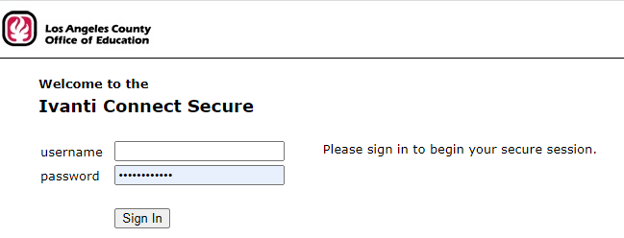
- Start Ivanti Secure. (The client must be installed in your computer to work)
You may have either one of this sessions:

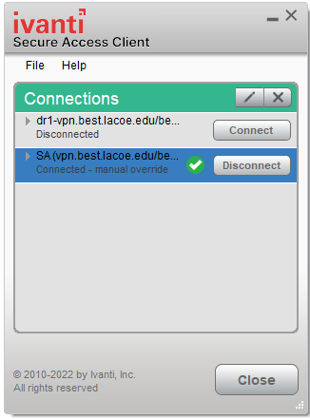
Make sure that Ivanti secure is connected. Check on your task bar that the Ivanti secure ICON has a RED Key with a green mark on the top right. Like this:



- Launch the Production and Training PRTG Map from the main Web Bookmarks:
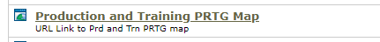

- The PRTG map will appear.
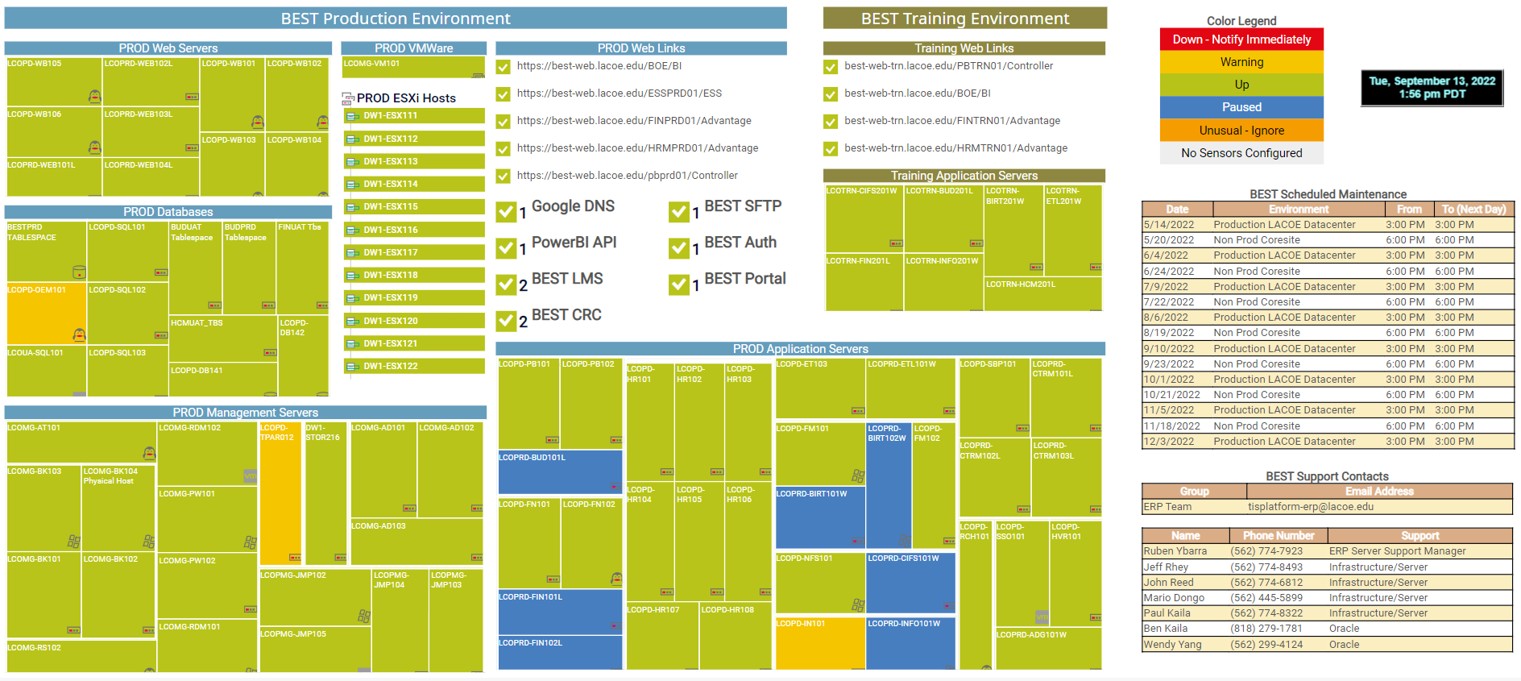

- Any Red alert on this map needs to be escalated as follows:

NOTE: Management has agreed that between the hours 7:00PM – 6:30AM, OPS could wait up to 30 minutes to see if the alert disappears. If alert is on the map for 30 minutes, start escalation process.

  - Check the section on the map labeled: “BEST Scheduled Maintenance”
  - If the red alerts fall on a scheduled Maintenance window you can ignore the alerts. If any alerts are present during these set times, the ERP team should be monitoring PRTG for any issues and will handle them as needed.
  - For any other alerts outside maintenance windows follow the next steps:
  - During normal business hours 7:00AM – 5:00PM Monday - Friday, the Help Desk is responsible for all escalations. OPS will call the Help Desk to inquire if they are aware of the issue as redundancy. The Help Desk must initiate a REMEDY ticket and do any follow ups. If needed, OPS team will send an email to TISplatform-erp@lacoe.edu with a short description of the alerts.
  - For after hours: 5:00PM – 7:00AM, OPS will be responsible to start the escalation process.
  - OPS team will send an email to TISplatform-erp@lacoe.edu with a short description of the alerts and start a calling procedure.
  - For any Server alerts. Call the primary on-call person for Infrastructure.
  - For any Database Alerts, Call the primary on-call person for Oracle.
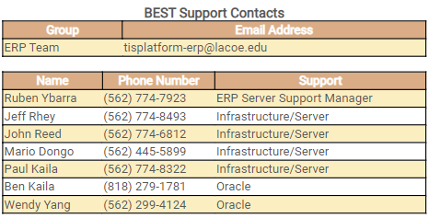
  - OPS receives every Friday an email with the primary and secondary ERP on call personnel and we use that email to update our announcements screen.
  - Call primary support on call if the alert remains for 30 minutes in PRTG.
  - If the on call person does not answer, leave a message and allow 5 minutes for a call back. After no response in 5 minutes, call the secondary person. Escalate to the manager of that area if the primary or secondary support person is not reached with 10 minutes.
  - When a support person is reached, inform them that a follow up call will be placed within 30 minutes to obtain an assessment of the situation.
  - Inform the OPS Supervisor or Senior Operator.
  - Follow up within 30 minutes after initially reaching support personnel.
  - If the support person determines that the problem resolution will take more than one hour to be resolved, call the ERP Server Support Manager (ESSM). Be prepared to provide times and estimates. The ESSM will provide direction on other calls to be made as necessary. If the ESSM is not available, contact the Director of Operations. The ERP team will be responsible for opening a Remedy ticket and all further escalations
  - The ESSM or ERP team will ensure that all escalations, follow ups and updates are done in a timely manner.

PRTG – ECS
- Logon to the ECS PRTG site:
https://prtg-main.internal.lacoe.edu/index.htm
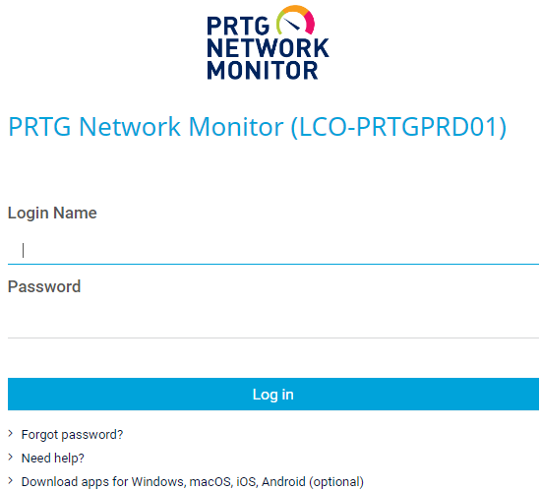
- Use the UserID and password provided by ECS and located in our check off sheets.
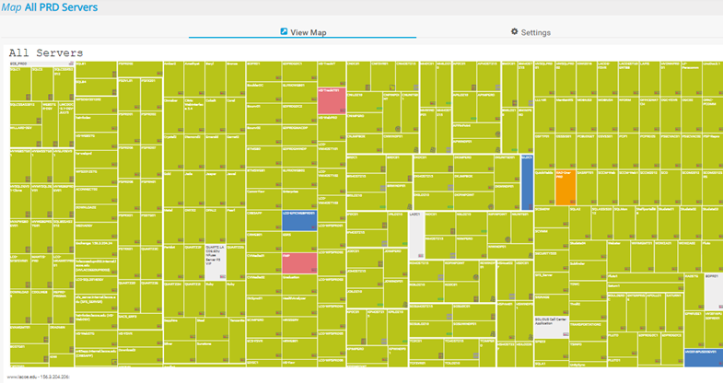
- Any Red alert on this map needs to be escalated as follows:

NOTE: Management has agreed that between the hours 7:00PM – 6:30AM, OPS could wait up to 30 minutes to see if the alert disappears. If alert is on the map for 30 minutes, start escalation process.

  - During normal business hours 7:00AM – 5:00PM Monday - Friday, the Help Desk is responsible for all escalations. OPS will call the Help Desk to inquire if they are aware of the issue as redundancy. The Help Desk must initiate a REMEDY ticket and do any follow ups.
  - For after hours: 5:00PM – 7:00AM, OPS will be responsible to start the escalation process.
  - OPS team will send an email to ECS Team: TSEnterpriseComputingServices@lacoe.edu with a short description of the alerts and start a calling procedure.
  - OPS receives every Friday an email with the primary and secondary ECS on call personnel and we use that email to update our announcements screen.
  - Call primary support on call if the alert remains for 30 minutes in PRTG.
  - If the on call person does not answer, leave a message and allow 5 minutes for a call back. After no response in 5 minutes, call the secondary person. Escalate to the manager of that area if the primary or secondary support person is not reached with 10 minutes.
  - When a support person is reached, inform them that a follow up call will be placed within 30 minutes to obtain an assessment of the situation.
  - Inform the OPS Supervisor or Senior Operator.
  - Follow up within 30 minutes after initially reaching support personnel.
  - If the support person determines that the problem resolution will take more than one hour to be resolved, call the ECS Server Support Manager (ESSM). Be prepared to provide times and estimates. The ESSM will provide direction on other calls to be made as necessary. If the ESSM is not available, contact the Director of Operations. The ECS team will be responsible for opening a Remedy ticket and all further escalations
  - The ESSM or ECS team will ensure that all escalations, follow ups and updates are done in a timely manner.

SEV1 – Network
- Logon to Network PRTG map for Districts using site:
Map: Network Services Dashboard 1
https://prtg-main.internal.lacoe.edu/map.htm?id=4948&tabid=1

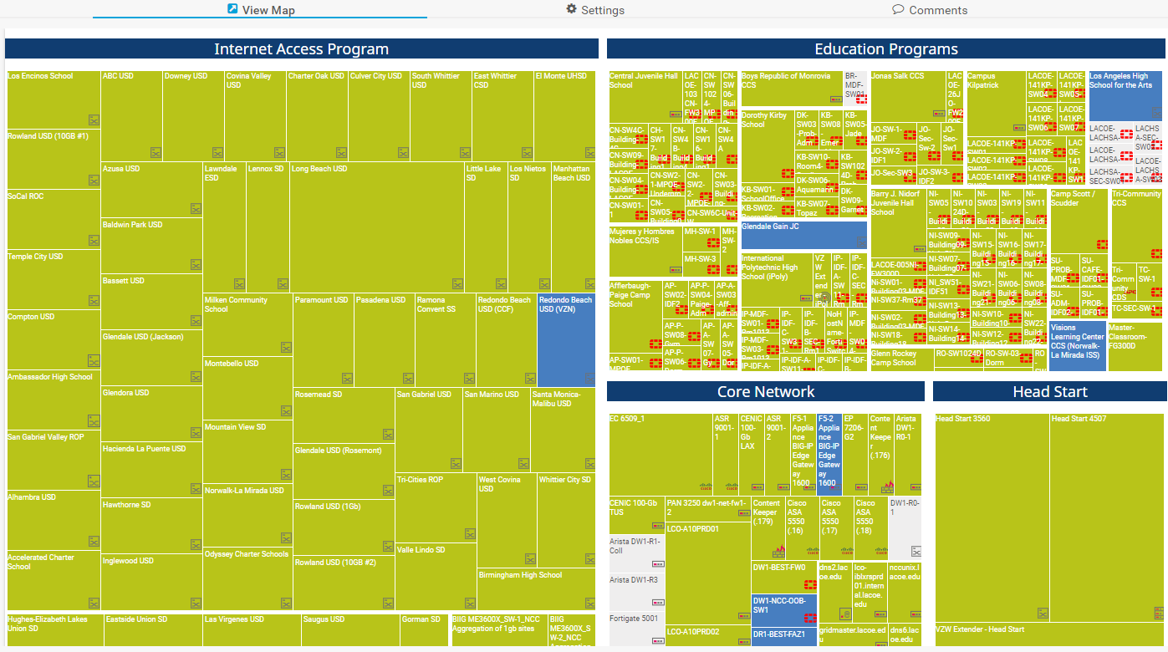

- Logon to Network PRTG map for Ed Center Buildings using site:
Map: Network Services Dashboard 2
https://prtg-main.internal.lacoe.edu/map.htm?id=8211&tabid=1

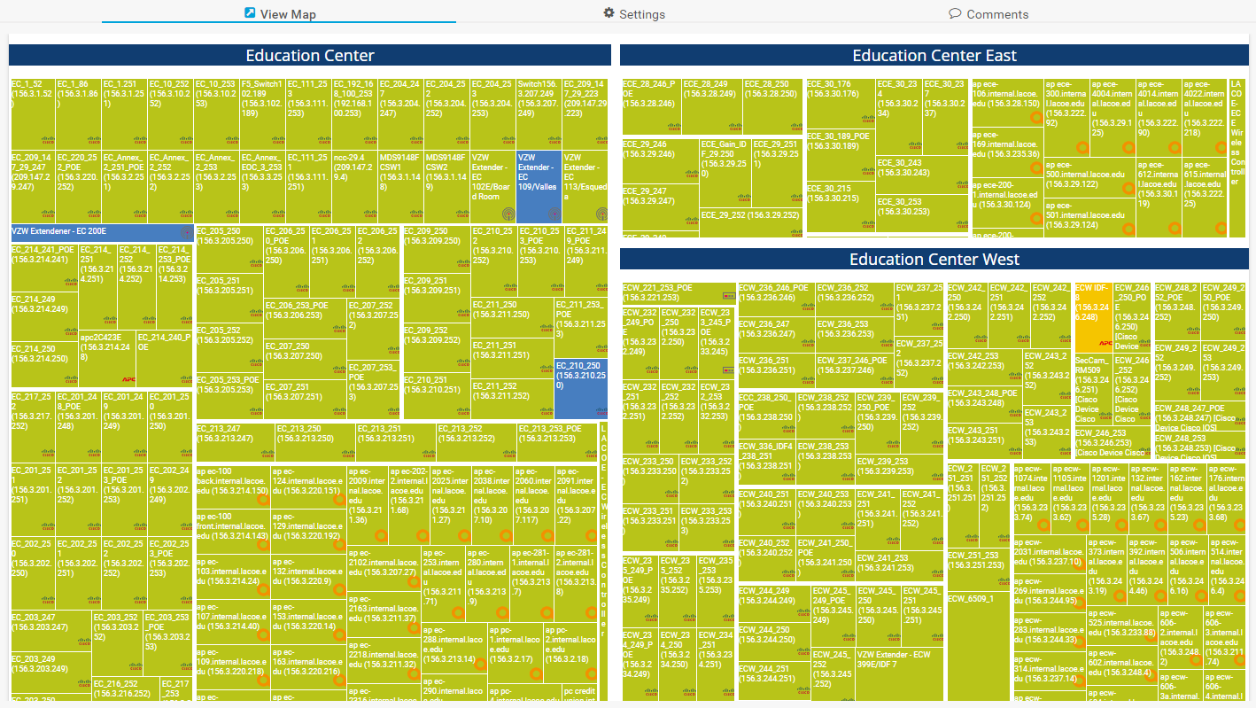

- Any Red alert on any of these two map needs to be escalated as follows:

NOTE: Management has agreed that between the hours 7:00PM – 6:30AM, OPS could wait up to 30 minutes to see if the alert disappears. If alert is on the map for 30 minutes, start escalation process.

  - During normal business hours 7:00AM – 5:00PM Monday - Friday, the Help Desk is responsible for all escalations. OPS will call the Help Desk to inquire if they are aware of the issue as redundancy. If they are not aware or not available, go to step 3.C below. Make sure that the Help Desk must initiate a REMEDY ticket and do any follow ups.

  - For after hours: 5:00PM – 7:00AM, OPS will be responsible to start the escalation process.

  - Send an email to the Helpdesk@lacoe.edu queue to generate an automated ticket.

  - OPS team will send an email to the Network Team: CircuitNotification@lacoe.edu with the following format:

  - Make sure that in the subject line you include the ticket number so the support can update it as needed.
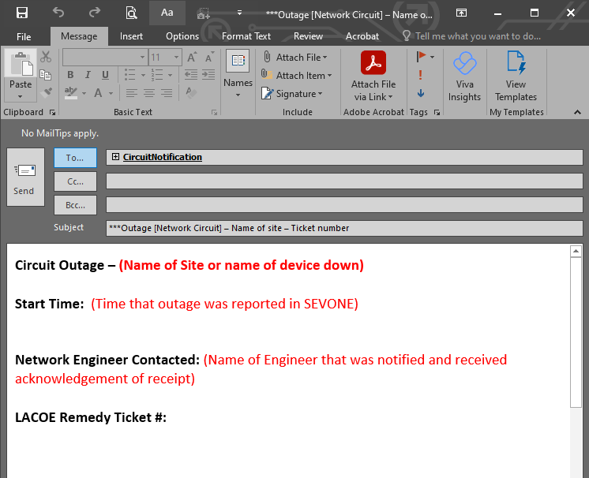
  - OPS receives every Friday an email with the primary and secondary Network Support on call personnel and we use that email to update our announcements screen.
  - Check for any emails from the network team to verify if the RED alert is caused by a planned outage. ( Pending Network team to include OPS on their notifications)
  - If escalation is needed follow steps 3.h – 3.n, otherwise you are done.
  - Call primary support on call if the alert remains for 30 minutes in PRTG.
  - If the on call person does not answer, leave a message and allow 5 minutes for a call back. After no response in 5 minutes, call the secondary person. Escalate to the manager of that area if the primary or secondary support person is not reached with 10 minutes.
  - When a support person is reached, inform them that a follow up call will be placed within 30 minutes to obtain an assessment of the situation.
  - Inform the OPS Supervisor or Senior Operator.
  - Follow up within 30 minutes after initially reaching support personnel.
  - If the support person determines that the problem resolution will take more than one hour to be resolved, call the Network Manager. Be prepared to provide times and estimates. The Network Manager will provide direction on other calls to be made as necessary. If the Network Manager is not available, contact the Network Director. The Network team will be responsible for opening a Remedy ticket and all further escalations
  - The Network Manager or Network support team will ensure that all escalations, follow ups and updates are done in a timely manner.

Contact Information
Each supporting area provides us with an email every Friday afternoon with their call-back support staff. Please check your emails and also look at the monitors in the data center with the current information on who is on call.
We are working on a common place where the On-Call support will be allocated. This is a work in progress but eventually it will be used for all escalations.
Please logon to this share document in share point:
CLICK -> HERE

